**Building a LAMP Stack Web Server**

**LAMP Stack Web Server**

**Introduction:**

The LAMP Stack Web Server is also known as Linux Web Server. It is a open-source web development platform used for building dynamic websites and web applications. LAMP stands for Linux, Apache, MySQL, and PHP/Perl/Python. These are the four main components required to setup a Web Server.

**Components of the LAMP Stack:**

**Linux (Operating System)**

• Linux servers as the fouldation of the LAMP stack. It Provides the Operating System on which the other components are installed and run.

• Linux distributions for LAMP Stack deployment include Ubuntu and Debian.

Apache (Web Server Software)

• Apache is a widely used open-source web server software that serves web content to clients over the internet.

• Apache handles HTTP requests from web browsers and delivers web pages.

• It extends various modules for extending its functionality.

**MySQL (Database)**

• It is a software which is used to maintain and manage the Database.

• It provides security and authorization are the important features of the DBMS.

• MySQL is commonly used in web applications to store user information and other data.

PHP/Per/Python (Server Side Shipting Language)

PHP, Perl, Python are the server-side scripting languages used for dynamic web development

• These languages enables developers to create interactive and dynamic web pages that respond to user input.

• PHP is mostly commonly used language in LAMP Stack.

Setting up a LAMP Stack Web Server

**Stepl: Install Linux**

• Before we are going to further you must need a Linux or One of Linux Distributions

Ubuntu by using this link https://ubuntu.com/download.

Step 2: Installing MySQL/Mariadb

• Now, install MariaDB server and client packages from the official package repository of Debian 10 with the following command:

C:\Users\Nanda Kumar\AppData\Local\Packages\5319275A.WhatsAppDesktop_cv1g1gvanyjgm\TempState\7F6FFAA6BB0B408017B62254211691B5\WhatsApp Image 2024-05-09 at 21.18.03_b91726d9.jpg

conform your Installation, Press Y to confirm or n to stop the process.

• If you want to check the status of mariadb server is running or not Enter the following command

C:\Users\Nanda Kumar\AppData\Local\Packages\5319275A.WhatsAppDesktop_cv1g1gvanyjgm\TempState\5FD0B37CD7DBBB00F97BA6CE92BF5ADD\WhatsApp Image 2024-05-09 at 21.20.12_135dbdd0.jpg

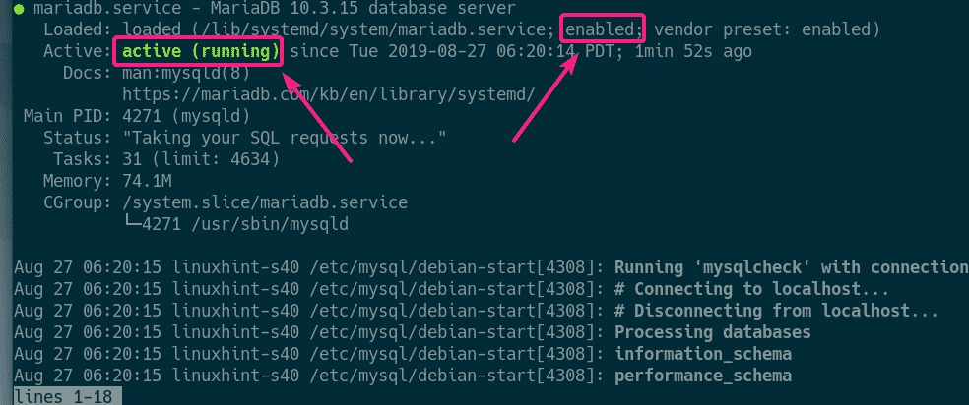

**Step-3:Install Apache2 and PHP**

* To install Apache2 and PHP in your Operating System use the following command and setup according to it

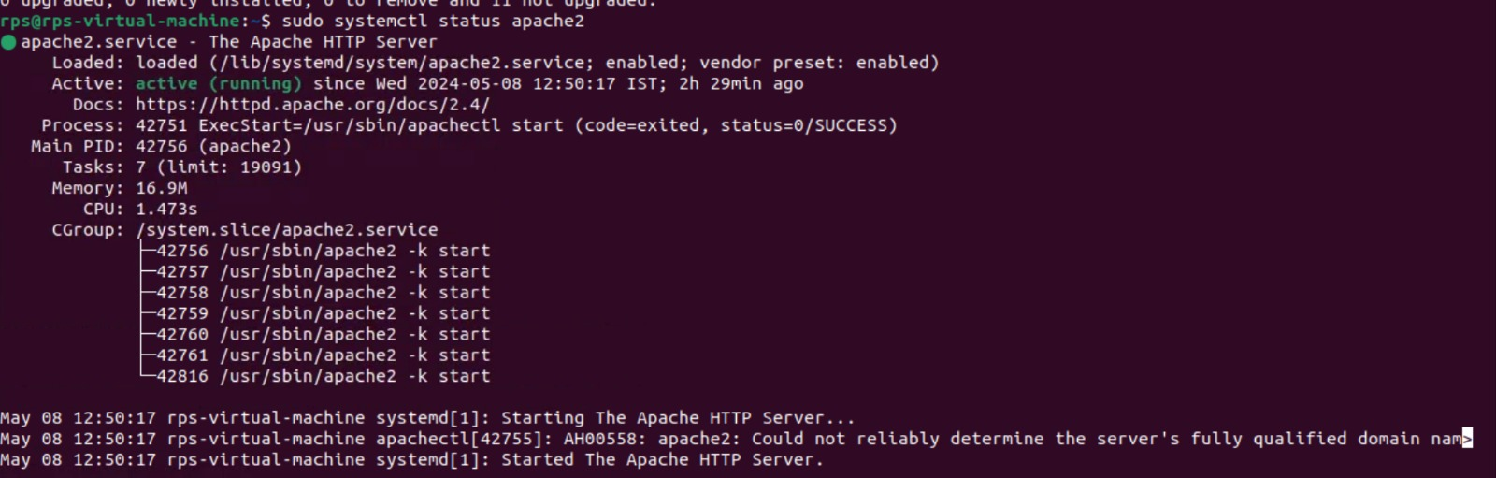

* After the installation done check the status of that server is running or not by using the following command

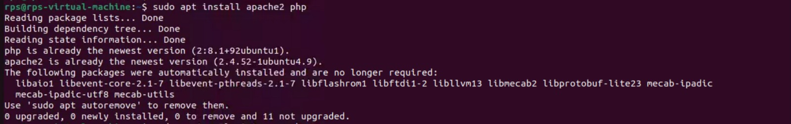

* To install the most common PHP extensions/libraries, run the folfwing command:

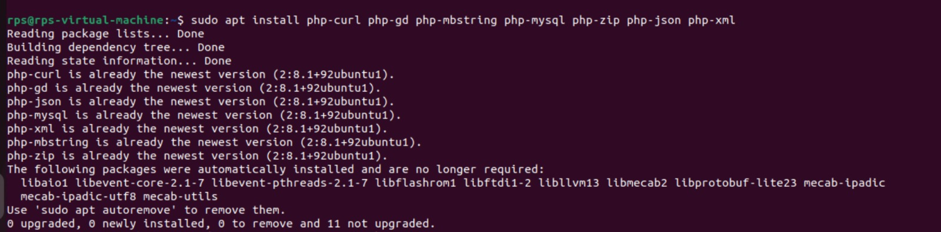

* Then, Again Restart the Apache2 Server by using following command

C:\Users\Nanda Kumar\AppData\Local\Packages\5319275A.WhatsAppDesktop_cv1g1gvanyjgm\TempState\069059B7EF840F0C74A814EC9237B6EC\WhatsApp Image 2024-05-09 at 21.36.58_e3d6a465.jpg

* To change the Apache run user, edit /etc/apache2/euvvars configuration file with the following command:

C:\Users\Nanda Kumar\AppData\Local\Packages\5319275A.WhatsAppDesktop_cv1g1gvanyjgm\TempState\76DC611D6EBAAFC66CC0879C71B5DB5C\WhatsApp Image 2024-05-09 at 21.38.45_946f233c.jpg

* Modify-the APACHE\_ RUN\_USER and APACHE\_ RUN\_GROUP enviroument variables.

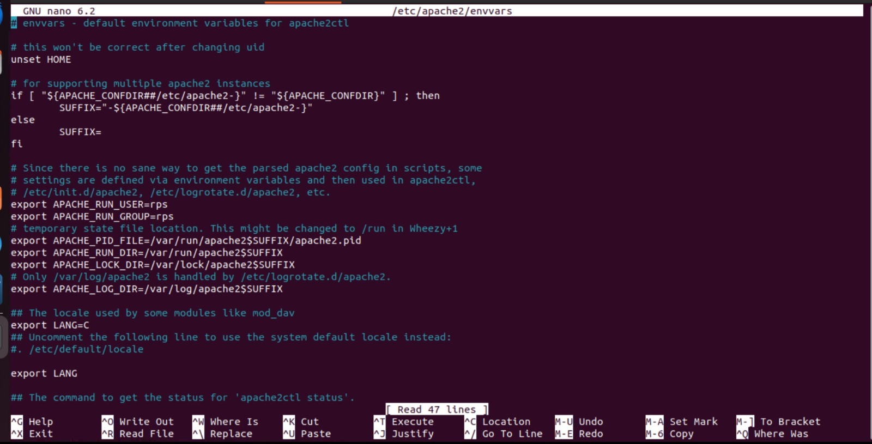

* Now, Instead of ps you have to give your root user. In this case my user is rps.
* Now, change the owner and group of the /var/www/html directory to the username of Your login user with the following command:

C:\Users\Nanda Kumar\AppData\Local\Packages\5319275A.WhatsAppDesktop_cv1g1gvanyjgm\TempState\42A0E188F5033BC65BF8D78622277C4E\WhatsApp Image 2024-05-09 at 21.46.47_94dda971.jpg

* I have created 2 PHP scripts index.php and phpinfo.php in the webroot /var/www/html.

**Contents of index.php:**

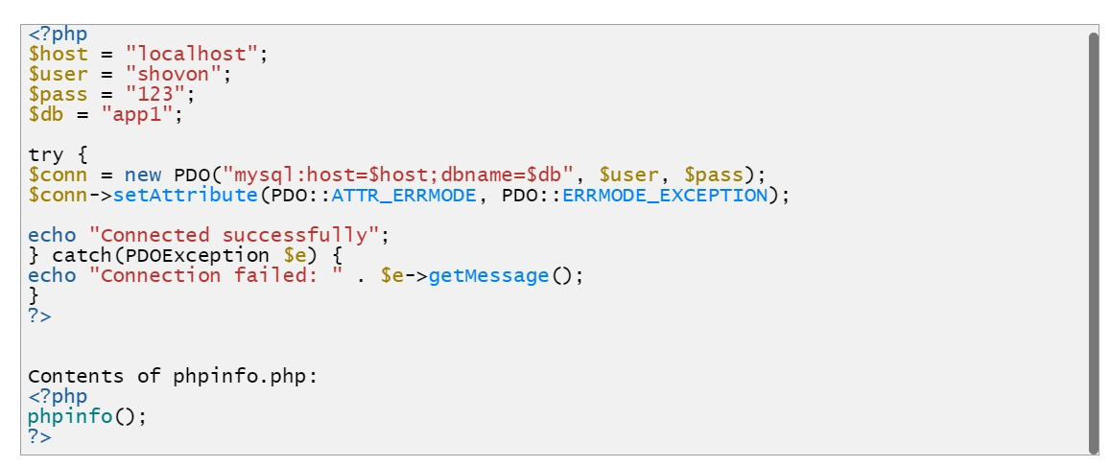

**Contents of phpinfo.php:**

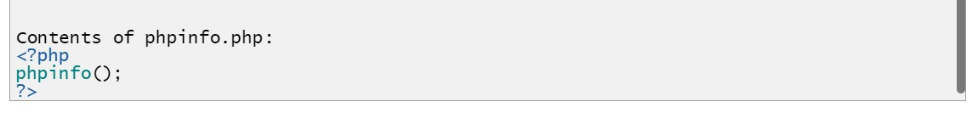

**http://localhost/**

**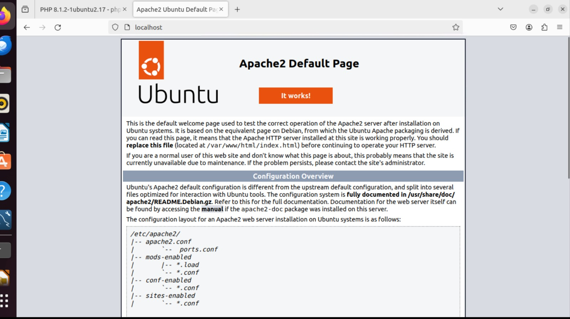**

[**http://localhost/phpinfo.php**](http://localhost/phpinfo.php)

**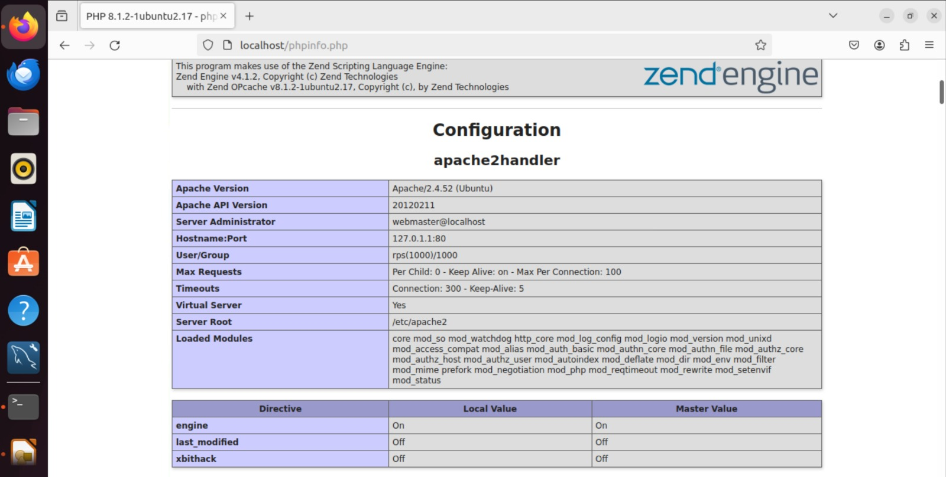**

**CONCLUSION:**

* So, that’s how you setup a Debian 10 LAMP server for PHP web development. Thanks you...